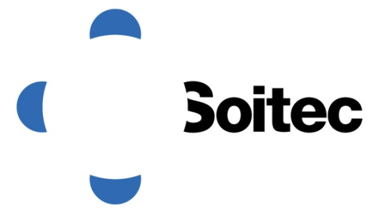

Results of the Combined Shareholders’ Meeting of 11 April 2016

Bernin, France, 12 April 2016 – The Board of Directors of Soitec (Euronext Paris), a world leader in manufacturing innovative semiconductor materials, has announced that the company’s Combined Shareholders’ Meeting was held on 11 April 2016, chaired by Mr. Paul Boudre, with a quorum of 25.82 % for the Ordinary General Meeting and a quorum of 26.95 % for the Extraordinary General Meeting.
The Ordinary General Meeting was able to vote, and all the resolutions falling within its competence were approved. The Extraordinary General Meeting was able to vote, except on the 7th and 8th resolutions, which could not be put to a vote on account of a lack of quorum; this was because Bpifrance was unable to vote its shares on these two resolutions, which concerned the planned capital increase reserved for it. The other resolutions presented at the Extraordinary General Meeting for which a quorum was reached (i.e. resolutions 9 to 17) were all approved.
Consequently, shareholders will be invited to meet on second call on 29 April 2016 and to vote on resolutions 7 and 8 in accordance with the notice published in the BALO official journal of 21 March 2016.
The Board points out that the implementation of the whole capital increase plan announced on February 10, 2016 depends on these resolutions, and that their approval is essential for Soitec to be able to carry out the reserved capital increases that will enable it to meet its repayment deadlines in May 2016.

Shareholders who have already voted by post or by proxy in response to the invitation to the EGM of March 21, 2016 do not need to return another voting form. Soitec’s Board of Directors strongly encourages shareholders who have neither voted by post nor appointed a proxy to cast their votes in response to this second call.

About Soitec

Soitec (Euronext, Paris) is a world leader in manufacturing innovative semiconductor materials. The company uses its unique technologies to serve the electronics and energy markets. With 3,600 patents worldwide, Soitec’s strategy is based on disruptive innovation to respond to its customers’ needs for high performance, energy efficiency and cost competitiveness. Soitec has manufacturing facilities, R&D centers and offices in Europe, US and Asia. For more information, please visit www.soitec.com. For more information, please visit www.soitec.com.

For all information, please contact:
Investors Relations  Steve Babureck  +33 (0)6 16 38 56 27 or +1 858 519 6230  steve.babureck@soitec.com  Individual Shareholder Relations  08 05 10 99 39  +33 (0)1 70 79 13 15  investors@soitec.com | Media Relations  Fabrice Baron  +33 (0)1 53 32 61 27  fabrice.baron@ddbfinancial.fr  Isabelle Laurent  +33 (0)1 53 32 61 51  isabelle.laurent@ddbfinancial.fr

